Theme: Leveraging Artificial Intelligence to Make Aviation Greener

AI Empowered Soaring Trajectory Planning – Next Gen Green Aviation Solution

WEI Wang ¹, YANG Luo¹, BINGYANG Zhang ¹, XIULAI Xu ¹, JIAXING Wang ¹ , YICHI Zhang ¹
¹ School of Aeronautics, Northwestern Polytechnical University, Xi’an, China, 710072

Abstract
Article Type:
Case Study

Collaboration: A cross-institutional collaboration and cross-industry collaboration

Citation: (to be generated)

Academic Editor:
Samie Ly
Cameron Welsh

Received: May 10, 2024
Accepted: November 4, 2024
Published: December 17, 2024

Publisher’s Note: WXP stays neutral with regard to jurisdictional claims in published maps and institutional affiliations.


Copyright: © 2024 by the authors. Submitted for possible open-access publication under the terms and conditions of the Creative Commons Attribution (CC BY) license (https://creativecommons.org/licenses/by/4.0/).

IN COLLABORATION WITH


With the rapid development of economic globalization, the demand for the aviation industry is increasing across various sectors. However, this growing demand has significant environmental impacts and repercussions for related industries. Many researchers have studied the topic of green aviation; nevertheless, a clear definition of green aviation remains elusive, leading to discrepancies in its implementation. To address this issue, this study employed a questionnaire survey to analyze the collected responses, ultimately defining green aviation as the rational use of energy, which includes reducing fuel consumption and enhancing energy efficiency. Based on these findings, this research proposes an AI-based soaring trajectory plan for green aviation. This method aims to utilize jet streams to enhance energy efficiency and lower greenhouse gas emissions, ultimately achieving green aviation and contributing to a better world.

Keywords: Green Aviation, Energy Efficiency, Soaring, Artificial Intelligence, Trajectory Planning

1.0 Introduction
With the rapid advancement of economic globalization, there has been a notable increase in the demand for the aviation industry across various sectors. Correspondingly, the development of the aviation sector has had significant implications for the environment and related industries. Regarding climate impact, the aviation industry stands out as one of the primary sources of greenhouse gas emissions. The combustion of fossil fuels during aircraft flights releases substantial amounts of carbon dioxide (CO₂), a leading contributor to global warming(Lyle). Additionally, the emission of nitrogen oxides (NOx) from aircraft at high altitudes contributes to ozone formation(ICAO,2020), intensifying the greenhouse effect. Moreover, the contrails produced by these emissions can alter the properties of cloud layers, thereby affecting the Earth's radiative balance(Lee,2010). At the same time, the aviation industry significantly impacts the socio-ecological environment. For instance, Correia et al. (2013) found that noise pollution from aviation affects the quality of life and health of residents living near airports. Their research indicated that for every 10-decibel increase in airport noise levels, there is an associated 3.5% rise in the average impact on hospital admissions/deaths due to cardiovascular diseases(Correia,2013).
Numerous research organizations have introduced the concept of green aviation to propose solutions to mitigate the environmental and social impacts associated with the aviation secto(Hagmann(2015) and Vespermann(2011),Zhang,Y(2020)). The genesis of green aviation can be traced to the turn of the 21st century, coinciding with a growing global emphasis on environmental conservation and sustainable developmen(Agarwal R K,2020).
By the 1990s, an elevated consciousness of environmental concerns had spurred the aviation industry to explore technological innovations designed to reduce carbon emissions and enhance fuel efficiency(Afonso F,2023). In the 2000s, the International Civil Aviation Organization (ICAO) endorsed the Kyoto Protocol, which required countries to reduce their greenhouse gas emissions, and the aviation industry was included in these reduction targets. Aircraft manufacturers such as Boeing and Airbus responded by introducing more fuel-efficient models, including the Boeing 787 and the Airbus A350, and began exploring the use of biofuels (Ficca A(2023) and Qiu R(2021)，Perez-Valls(2016)). During the 2010s, ICAO adopted the Carbon Offsetting and Reduction Scheme for International Aviation (CORSIA), marking a significant step in the regulation of international aviation emissions. This period also saw substantial advancements in electric aircraft development and increased support for the research and deployment of Sustainable Aviation Fuels (SAF)(Hoelzen J(2022) and Blockley R(2016)). In the 2020s, many airlines and nations have committed to net-zero emission goals. Significant technological breakthroughs in electric and hybrid-electric aircraft have been achieved, and governments have introduced more supportive policies and financial incentives (Platzer M F(2023) and Perez-Valls(2016)). International cooperation has become a key driver in advancing the green aviation agenda. The development of the green aviation concept is a multifaceted process involving collaborating with various stakeholders and integrating multiple technologies. It encompasses policy frameworks, technological innovations, and market dynamics. As global awareness of environmental protection continues to rise, green aviation is emerging as a critical pathway for the future sustainability of the aviation industry.
Based on the literature above, it is evident that the definition of green aviation remains ambiguous. Depending on the definition, researchers propose different directions for its development. For instance, some define green aviation as the concept of sustainability or net-zero greenhouse gas emissions in the context of aviation operation(Ranasinghe K(2019)), while others view it as an approach to enhancing aircraft efficiency by reducing noise levels, greenhouse gas emissions, and carbon footprints(Lai Y Y,2022). Therefore, this study aims to define green aviation and explore the corresponding implementation methods through a survey-based research methodology. By conducting interviews with industry insiders and external stakeholders, the study analyzes their understanding of green aviation and identifies the key issues that need addressing. Based on the findings, this research identifies three major pain points and proposes potential solutions from the perspective of artificial intelligence.

2.0 Method

2.1 Questionnaire Survey Overview
In defining green aviation, we adopted a survey methodology comprising fill-in-the-blank and multiple-choice questions designed to capture participants' perceptions, knowledge, and opinions regarding green aviation. This data will aid the International Association for Green Aviation in formulating strategies and proposing global initiatives that effectively address the needs of all stakeholders within the aviation sector. The survey underscored its voluntary, anonymous, and singular purpose nature. To safeguard participant data, IAGA instituted stringent confidentiality protocols and processing measures.
The survey presents several advantages. Firstly, it facilitates the collection of extensive quantitative and qualitative data, thereby offering a holistic understanding of public perspectives on green aviation. The standardized question format enhances data organization and analysis while enabling comparative assessments of results. Furthermore, surveys are relatively cost-effective and can amass substantial sample sizes quickly. The assurance of anonymity encourages respondents to articulate their views candidly, thus ensuring authenticity and reliability in the collected data.

2.2 Data Collection
We employed a primary online and secondary offline strategy regarding the questionnaire distribution. The online distribution primarily involved disseminating questionnaires via email and social media platforms, facilitating extensive outreach. Offline distribution occurred at airports and airline counters, directly engaging the target audience. This demographic is more likely to be concerned with aviation-related issues due to their transportation choices. Integrating both online and offline methods ensures coverage across diverse audience segments, thereby enhancing the comprehensiveness of the survey. Furthermore, targeted outreach to specific groups, such as frequent travelers and aviation industry professionals, allows for collecting more nuanced feedback.
Through these methodologies, the questionnaire survey effectively gathers and analyzes data pertinent to green aviation, yielding valuable insights to promote sustainable development within the aviation sector.

2.3 Questionnaire Classification
The green aviation questionnaire survey is divided into four main sections, aiming to comprehensively understand the public's perception, views, and attitudes towards green aviation and provide a basis for the International Association for Green Aviation to develop effective policies and action measures. The four sections comprise 19 major questions and 85 specific sub-questions, as shown in Figure 1.
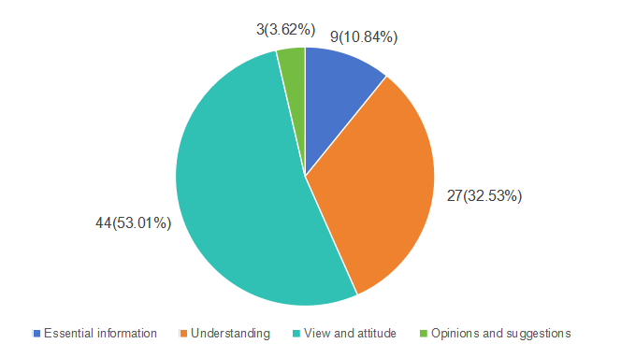
Figure 1. Questionnaire Classification
Here is a detailed classification of the questionnaire and an in-depth description of each category:
(1) Essential Information
This section aims to collect basic personal information from respondents to analyze the views and attitudes of different groups toward green aviation. By collecting data on gender and age, researchers can understand the differences in opinions between different gender and age groups. The highest level of education may affect respondents' understanding of green aviation technology. Unit and occupation information can reflect whether respondents' industries are related to aviation or sustainable development, which may influence their views and attitudes. Specific work and functions can help understand the responsibilities and participation of practitioners in different positions and functions in green aviation initiatives. This basic information lays the foundation for an in-depth analysis of different social groups' attitudes towards green aviation.
(2) Level of Understanding
This section assesses respondents' level of understanding and depth of knowledge about green aviation initiatives. The survey questions may include whether respondents are familiar with the latest technological advancements, such as more efficient aircraft designs or the application of new materials, their understanding of the use of renewable energy in the aviation industry, such as biofuels or electric aircraft. Additionally, the survey will evaluate respondents' awareness of international (such as the United Nations) and national green aviation strategies, goals, and regulations. These questions help determine the public's level of knowledge about green aviation, guiding education and outreach activities.
(3) Views and Attitudes
This section explores respondents' attitudes and perceptions towards green aviation, including confidence, impact, and willingness to participate or disseminate information. This section contains nearly 50 simple questions and is the most critical analysis module in the questionnaire. Through these questions, researchers can obtain respondents' confidence in the implementation of green aviation initiatives, explore how green aviation initiatives affect respondents' career development or work content, understand whether respondents are willing to participate in the implementation of green aviation initiatives actively, or whether they are willing to spread the concept of green aviation to colleagues or friends. These data are crucial for evaluating public support and developing effective promotion strategies.
(4) Opinions and Suggestions
This section will collect respondents' specific views and suggestions on green aviation's future development and challenges. Questions may include respondents' opinions on the path and methods to achieve carbon neutrality in aviation; discussions on the main challenges faced by green aviation in terms of technology, economy, and policy; and the conditions under which green aviation goals can be achieved, or the reasons for skepticism about their achievement. By collecting this information, researchers can better understand the public's expectations and concerns about green aviation, providing targeted suggestions for policy-making.
Analyzing the survey results by making these questions more specific can provide a more detailed understanding of different groups' views and attitudes towards green aviation initiatives, laying a solid foundation for developing more targeted policies and actions. This survey contributes to the development of green aviation and supports the achievement of global sustainable development goals.

3.0 Results
This questionnaire aims to investigate participants' understanding and attitudes towards the concept of green aviation. We aim to initiate a series of discussions on green aviation from the perspectives of participants' multiple identities, including the effectiveness and usability of green aviation, participants' willingness to practice green aviation, and the impact of green aviation on their future development prospects. The current survey results are as follows.

3.1 Analysis of Participants' Basic Information
The total sample size of participants in this survey is 65, with 23 females and 42 males, accounting for 64.62% of the total. Most participants (58) are under the age of 24, making up 89.23% of the sample, while only 6 participants fall within the age range of 24 to 40. Only one participant above the age of 41 participated in this survey. In terms of educational background, the majority of participants (31) hold a bachelor's degree, accounting for 47.69%, followed by 15 participants with a high school diploma, 18 participants with a master's degree, and only 1 participant with a vocational degree, making up 1.5% of the sample. The statistics of the basic information are presented in Table 1.
Table 1. Participants' Basic Information Statistics
Gender
Male |  |  |  |  |  |  |  | Female
42 |  |  |  |  | 64.62% |  |  | 23 |  |  |  | 35.38%
Age
Under 24 |  |  |  |  |  | 24-40 |  |  |  | Above 41
58 |  |  | 89.23% |  |  | 6 |  | 9.2% |  | 1 |  |  | 1.5%
Highest level educational level completed
Elementary |  | High school |  |  |  | Undergraduate |  | Graduate |  | Technical school |  |  | No education
0 | 0% | 15 |  | 23.08% |  | 31 | 47.69% | 18 | 27.69% | 1 | 1.5% |  | 0 | 0%
The majority of participants identified as students, with a total of 39 students participating in the survey. In addition, there are a waiter and a factory owner.The remaining participants did not disclose their occupation.
According to the statistical data, 12 participants were from Vanier University, 20 were from Northwestern Polytechnical University, 4 were from Civil Aviation University of China, 2 were from the factory of China, 1 was from Shanghai Jiao Tong University, 1 was from Tianjin Normal University, 1 was from Northwest University, 1 was from Innovatank, 1 was from Tongji University, and 1 was from Technical University of Munich. The remaining participants did not specify the name of their affiliated institution.
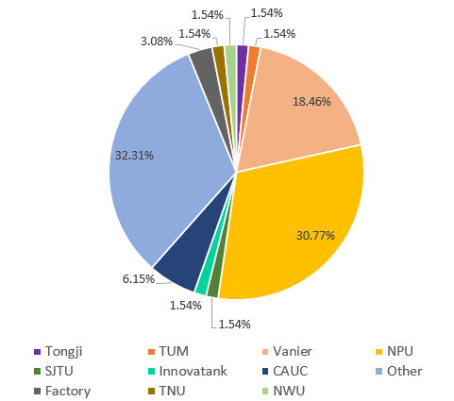
Figure 2. Occupation and Affiliated Institution
Fourty-two participants reported that their job position was at the grassroots level, 2 was at the middle level, and 3 was at the senior level, while the remaining participants did not specify their job category. In terms of job functions, 35.38% of participants were involved in technical implementation, 13.85% in decision-making, 13.85% in planning, 6.15% in administrative management, and 3.08% in policy-making, while 27.69% left this section blank. The data showed that in terms of work involvement, "implementation" had the highest proportion, at 29.23%, followed by "project formulation" and "evaluation", 15.38% and 13.85% respectively. However, 29.23% of participants did not select any option. According to the open-ended question that asked participants to describe their job functions, it was found that most participants, although students, had already been involved in various aspects of aviation, such as flight vehicles, design analysis, and other related issues.
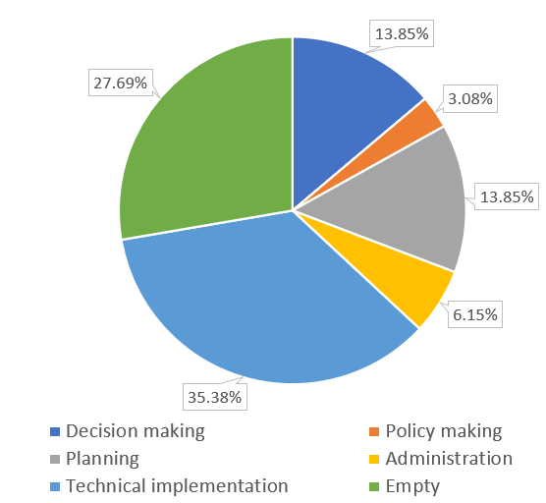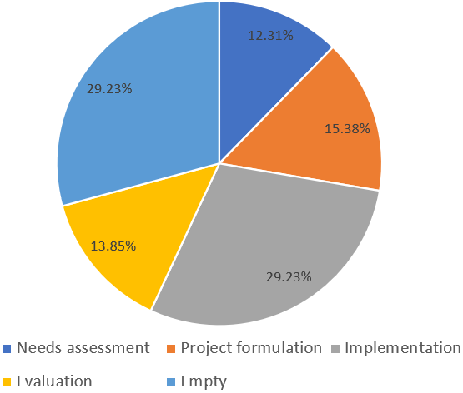
Figure 3. Job Functions

3.2 Survey Results
The survey showed that most respondents had heard of the concept of green aviation, with a proportion of 70.77%, while 29.23% of respondents had not heard of it, indicating that the promotion of green aviation had achieved a certain effect.
Regarding the related concepts and content of green aviation, the respondents mentioned airport green initiatives, aircraft improvements, aircraft engine improvements, sustainable alternative fuels, carbon reduction initiatives, electric aircraft, hydrogen energy, greenhouse gases, aircraft manufacturing, air traffic management, carbon tax, digital circular economy, sustainable aviation, European Single Sky, 2050 goals, EU carbon reduction 55% package, green airport certification, flight passenger tax, International Civil Aviation Organization, International Aviation Carbon Offset and Reduction Plan, United Nations Sustainable Development Goals, carbon trading tax, and aircraft flight optimization. Figure 4 and Figure 5 illustrate the respondents' level of understanding of these green aviation-related concepts.
In Figure 4, the data on the respondents' understanding of green aviation is integrated, with the blue, orange, gray, yellow, and green colors representing "not understanding", "understanding a little", "understanding relatively well", "understanding very well", and "professional-level understanding" from left to right. The data in the figure shows that although 70% of respondents had heard of green aviation, most people had little or no understanding of the specific concepts of green aviation. Overall, the respondents' understanding of related concepts was mostly below the level of "understanding relatively well", and only a small proportion of professional personnel had a deep understanding of green aviation-related concepts and had researched them. This may be because most related concepts are relatively new or have a high degree of professionalism, leading to a lack of attention from the public. For example, the proportion of people who did not understand the European Single Sky, the EU's 55% carbon reduction package, and green airport certification was more than 50%. In comparison, the proportion of people who did not understand carbon reduction initiatives and greenhouse gases was less than 20%. It is worth noting that there are significant differences in the understanding of different concepts, such as the understanding of greenhouse gases, which is mostly at the level of "understanding relatively well", while the understanding of flight passenger tax, green airport certification, and European Single Sky is mostly below 10%. This reflects the differences in the public's awareness of different fields and the need to strengthen the promotion and popularization of some initiatives.
In addition, the survey also discussed other green aviation initiatives. However, almost all respondents said they did not understand them, and only one or two mentioned the EU protocol and the Battery 500 project. This indicates that green aviation-related initiatives have not yet gained high recognition among the public.
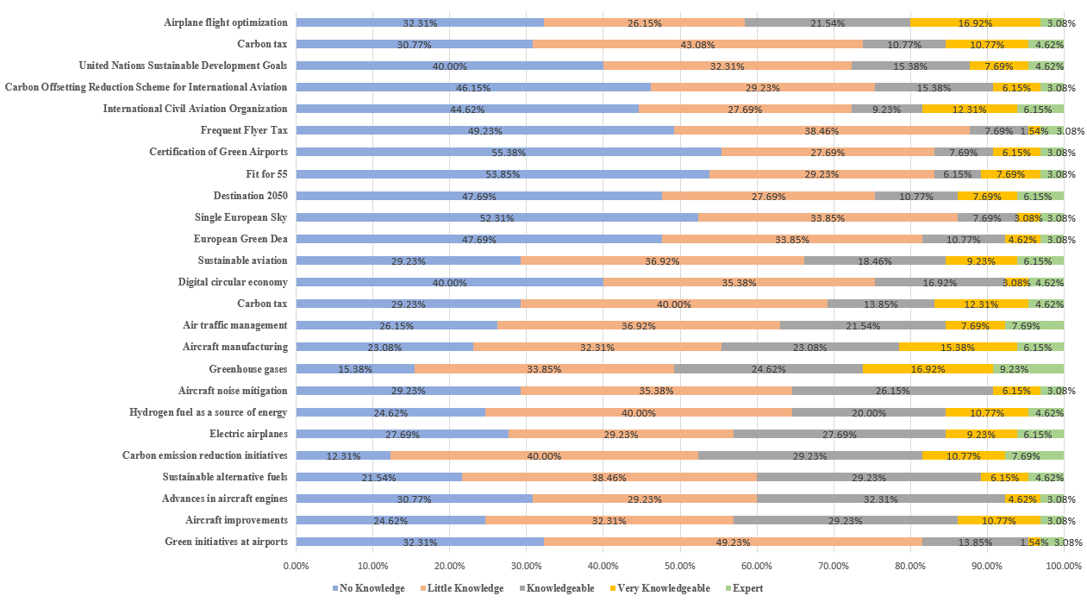
Figure 4. Distribution of Understanding of Green Aviation Concepts
Figure 5 shows the respondents' attitudes and support for green aviation. In fact, for most opinions, more than 50% of respondents still hold a neutral attitude, which may be due to the lack of clear understanding of green aviation, leading to difficulty in accurately expressing their opinions and thus hesitating between agreement and disagreement. Of course, most respondents also expressed their willingness to participate in green aviation initiatives, including wanting to learn more about related information, incorporating it into their work and organization, and self-education and training.
Among all opinions, respondents generally agreed or were neutral about the view that green aviation initiatives are beneficial for mitigating climate change, with nearly 80% of respondents agreeing with this view, indicating that people hold a positive attitude towards green aviation improving climate change and are very optimistic about it. The second most widely accepted view was the desire to learn more about green aviation, with nearly 73% of respondents agreeing and only 7.5% disagreeing, indicating that people are optimistic about understanding and recognizing green aviation concepts, which is very important for the future development of green aviation. However, the views on "I am confident in my knowledge of green aviation" and "I am confident in my ability to address green aviation challenges" were met with more than 64% of respondents choosing to disagree or remain neutral, which also indirectly indicates the lack of understanding of green aviation and the urgency of learning more about it.
Overall, people still hold a positive attitude towards green aviation initiatives, including believing that green aviation initiatives can help achieve climate goals, mitigate climate change, align with their own interests, trust green aviation, support aviation organizations taking action, and believe that participating in green aviation initiatives is beneficial for work and personal development. The large number of neutral respondents may only be due to the current lack of clarity on green aviation concepts or the lack of understanding of related measures, and it is believed that after fully understanding green aviation, people's attitudes will significantly change.
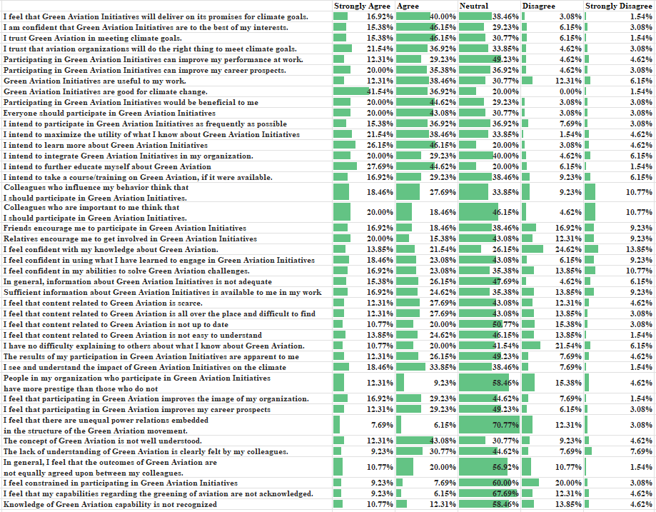
Figure 5. Opinions on Green Aviation
A preliminary discussion on specific opinions within green aviation was conducted through the survey, with a heated debate focusing on the issue of carbon neutrality. The main perspectives on the best ways for the aviation industry to achieve carbon neutrality included using sustainable and recyclable aviation fuels and adopting new technologies to utilize clean energy. Some respondents also suggested the need to optimize engine and aircraft structure weight. The major challenges identified for achieving carbon neutrality in the aviation sector were primarily the concern about profit costs for airlines and the low maturity of related technologies. Regarding whether the aviation industry will ultimately achieve carbon neutrality, over 80% of respondents expressed optimism that it will be achieved, although many acknowledged that this is not a short-term goal. These discussions have provided some strategic insights for the future development of carbon neutrality. Additionally, a majority of respondents expressed support for registering for a Green Aviation Management Certificate with the International Green Aviation Association , indicating a positive outlook for the development of green aviation.

4.0 Pain Point Analysis and Solutions
With the rapid growth in global air transport demand, the energy consumption of the aviation industry is also increasing swiftly. This trend not only poses higher operational cost challenges for airlines but also exerts greater pressure on the global environment. This challenge has prompted experts and companies both within and outside the industry to actively explore innovative solutions to achieve more sustainable and greener aviation.
One of the key challenges in green aviation is how to improve energy efficiency to achieve more environmentally friendly and sustainable flight methods. To address this, we propose an innovative solution that combines traditional fossil fuels with wind energy, drawing inspiration from the gliding flight of birds in nature. By studying how birds utilize airflow and wind to glide for extended periods, we can develop flight technologies capable of efficiently capturing and utilizing wind energy in the air. The core of this solution is to design a flight system that can intelligently adjust according to wind conditions, enabling aircraft to achieve optimal energy efficiency in various wind environments. This reduces reliance on fossil fuels, lowers carbon emissions, and advances green aviation technology.

4.1 High-altitude Jet Stream and Soaring
The jet stream refers to a strong and narrow band of winds located between the top of the troposphere and the bottom of the stratosphere, typically at altitudes ranging from 7 to 16 kilometers. It forms primarily due to atmospheric pressure gradients caused by temperature differences on the Earth's surface, and it is particularly pronounced between winter and summer.
Jet streams hold significant potential for development in green aviation, as evidenced by the following points: Firstly, jet streams can substantially influence flight time and fuel consumption. When an aircraft flies in the direction of a jet stream, it can harness the powerful thrust of the jet stream, thereby reducing flight time and fuel consumption. For example, flights from North America to Europe often choose to fly along the polar jet stream to significantly shorten flight times. Secondly, by fully considering the impact of jet streams when planning flight routes, airlines can optimize flight efficiency and reduce fuel consumption, thereby minimizing their environmental impact.
Birds possess exceptional skills in utilizing natural air currents to reduce energy consumption during flight. They demonstrate remarkable energy-saving abilities while gliding, efficiently using natural airflows and wind to minimize energy expenditure and extend flight time and distance researched by Tobalske et al. (2007). Physiological measurements indicate that the cost of gliding for a herring gull is only 2.17 times its basal metabolic rate (BMR) researched by Steele et al. (1974), as the flight muscles are not actively engaged but merely maintain a flapping wing posture. Albatrosses can fly thousands of kilometers by converting the energy from speed gradients above the ocean into potential energy researched by Harvey et al. (2021).
Birds' gliding techniques primarily involve utilizing updrafts and tailwinds. Updrafts, including thermal and orographic lifts, provide additional lift, allowing birds to maintain or even gain altitude without flapping their wings. Tailwind flying refers to birds flying in the direction of the wind, using wind power to reduce air resistance and thus lower energy consumption. When gliding with the wind, birds optimize their aerodynamic performance by adjusting the angle and shape of their wings. Their wings have special structures and shapes that offer the best lift-to-drag ratio under various flying conditions. For instance, large raptors like eagles and vultures spread their wings wide during gliding to capture more updrafts. They also fine-tune the tilt of their wings to maintain balance and direction.
Commercial aircraft can also draw inspiration from birds' gliding techniques to enhance flight efficiency and reduce fuel consumption. Firstly, aircraft can optimize flight paths by utilizing natural air currents such as high-altitude jet streams. By flying in the direction of the jet stream, aircraft can harness wind power to reduce air resistance and achieve tailwind flight, thereby lowering fuel consumption. Secondly, aircraft can adjust flight altitude and routes to take advantage of updrafts. Although commercial planes cannot directly utilize thermal and orographic lifts like birds, they can improve flight stability and efficiency by selecting appropriate altitudes and routes to avoid turbulence and unstable air currents. For example, when flying over mountains, aircraft can choose higher altitudes to avoid turbulence caused by orographic lifts, ensuring a smoother and safer flight.

4.2 Technical Background
Dynamic soaring is a technique that utilizes the varying strength or direction of horizontal winds to support flight. Rayleigh was the first to propose that sustained flight could be achieved in a horizontally non-uniform wind field, categorizing dynamic soaring into four phases: "Windward Climb," "High Altitude Turn," "Leeward Descent," and "Lower Altitude Turn" (Rayleigh et al., 1883). The general strategy for dynamic soaring involves the aircraft climbing against the wind gradient to gain altitude, then diving with the wind to gain speed. Under appropriate conditions, the energy gained from such a trajectory can sustain continuous flight.
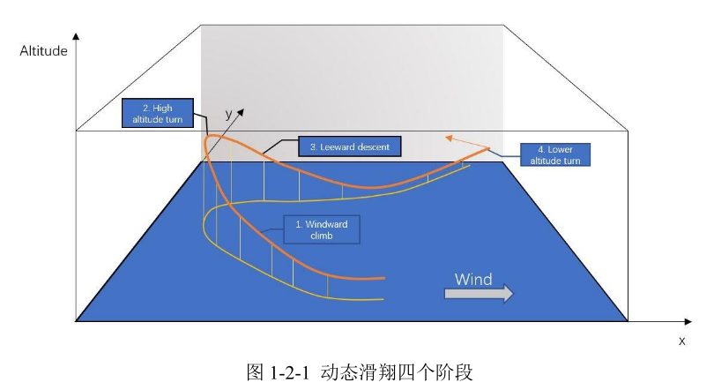
Figure 6. Dynamic Soaring Trajectory
It is well known that seabirds like albatrosses use dynamic soaring to travel hundreds of kilometers in a day. Therefore, in aircraft design, exploring the principles by which birds utilize wind energy for gliding can inform the design assessment for achieving energy-harvesting glides in aircraft, thereby significantly enhancing flight performance and directly reducing the aircraft's energy consumption and carbon emissions.
Utilizing jet streams for gliding has multifaceted implications for green aviation. By leveraging jet streams, aircraft can not only extend their flight duration but also substantially reduce fuel consumption, directly decreasing the emission of carbon dioxide and other greenhouse gases, which is crucial for addressing global climate change. Efficient utilization of jet streams can also optimize flight paths, minimizing unnecessary detours and waiting times, improving fuel efficiency, significantly extending flight range, and reducing reliance on ground support facilities. Reduced fuel consumption also directly lowers operational costs for airlines, ultimately enhancing the economic benefits of the entire aviation industry.
To utilize jet streams for gliding, it is essential first to understand the energy acquisition mechanism during gliding. This mechanism can be mathematically modeled and expressed as an energy-harvesting gliding mechanism model, composed of energy acquisition control equations that fundamentally reflect the change in energy over time. From the energy acquisition mechanism model, the changes in energy can be quantified, allowing for real-time calculation of energy variations. Furthermore, potential factors influencing energy acquisition can be extracted from the energy acquisition control equations, facilitating the analysis of energy acquisition patterns.
This paper establishes an energy-harvesting gliding mechanism model in a non-inertial coordinate system, derives the energy acquisition control equations, and conducts corresponding extraction and analysis of influencing parameters, thus elucidating the energy acquisition mechanism under jet stream gliding.
In the classical mechanics framework, a reference frame that satisfies Newton's laws of motion is referred to as an inertial reference frame, while a reference frame that does not satisfy these laws is termed a non-inertial reference frame. In a non-inertial coordinate system, the kinetic energy velocity of a moving object is the airspeed. Newton's second law and the mechanical energy equation can be written as:
（1）
（2）
Combining the above equations with equation (3) yields the rate of change of kinetic energy in a non-inertial reference frame:
（3）
Expanding the energy acquisition control equation in a non-inertial reference frame yields:
（4）
Equation (4) is the energy acquisition control equation for gliding in a non-inertial coordinate system. It can be seen that the work done by drag in the direction of airspeed is always an energy-consuming term and is proportional to the cube of the airspeed, while other terms may be energy-gaining terms and are proportional to the first or second power of the speed. It can be observed that:
- When there is an upward current or the inertial term is positive, the aircraft can acquire energy.
- The sign of the inertial term is controlled by the combination of ground speed and wind speed, which can be divided into climbing conditions and descending conditions.
- Under climbing conditions, assuming the wind speed is in the positive direction, if the ground speed is less than the wind speed, energy can be acquired. However, since the aircraft's minimum speed is usually greater than the wind speed, the condition for energy acquisition is met in the headwind situation.
- Under descending conditions, assuming the wind speed is in the positive direction, if the ground speed is greater than the wind speed, energy can be acquired. Since the aircraft's minimum speed is typically greater than the wind speed, the condition for energy acquisition is met in the tailwind situation
Through the analysis of the aircraft's energy acquisition under the energy acquisition mechanism model in a non-inertial reference frame, the following conclusions can be drawn:
1) From the perspective of energy changes, energy comes from the work done by aerodynamic forces, gravity, and inertial forces, while drag primarily performs negative work, continuously consuming the aircraft's energy. Gravity and inertial forces can perform positive work under certain conditions, providing energy to the aircraft.
2) The aircraft can achieve positive energy acquisition in environments with ascending currents, headwind climbs, and tailwind descents. The source of energy in ascending currents is the work done by gravity (increase in potential energy), while the energy in headwind climbs and tailwind descents comes from the work done by inertial forces.
3) For environments like jet streams, which have persistent velocity gradients, conditions exist that support efficient long-term gliding flight for aircraft.

4.3 The AI Empowered Soaring Achievement
(1) The Necessity of Combining Traditional Fossil Fuels with Wind Energy
As the aviation industry rapidly develops, fuel consumption and carbon emissions have become major challenges in global environmental protection. Although new technologies, such as electric aircraft, are under development, long-duration, efficient flights still rely on traditional fossil fuels due to the current limitations of energy storage technology. However, solely depending on fossil fuels for aviation is insufficient to meet the increasingly stringent energy-saving and emission-reduction requirements. Therefore, it is urgent to explore a transitional solution that improves energy utilization efficiency without completely abandoning traditional energy sources.
A solution that combines the efficient use of wind energy with fossil fuels offers a viable path forward. The jet stream, as a high-speed, stable natural phenomenon in the atmosphere, contains considerable energy. By employing AI technology for dynamic flight path planning, aircraft can make full use of wind energy while gliding with a tailwind, thereby reducing the load on the propulsion system and saving fuel. At the same time, under headwinds or other adverse conditions, aircraft can rely on fossil fuels to provide power, ensuring stability and safety during flight.
This combination of fossil fuels and wind energy not only significantly improves flight efficiency and reduces energy consumption, but also serves as a crucial transitional approach towards fully green aviation. It is both practically feasible and economically beneficial. Additionally, this solution can alleviate reliance on traditional fuels and provide the time and technological accumulation needed for a gradual transition to fully renewable energy in the future.
(2) Technology Roadmap
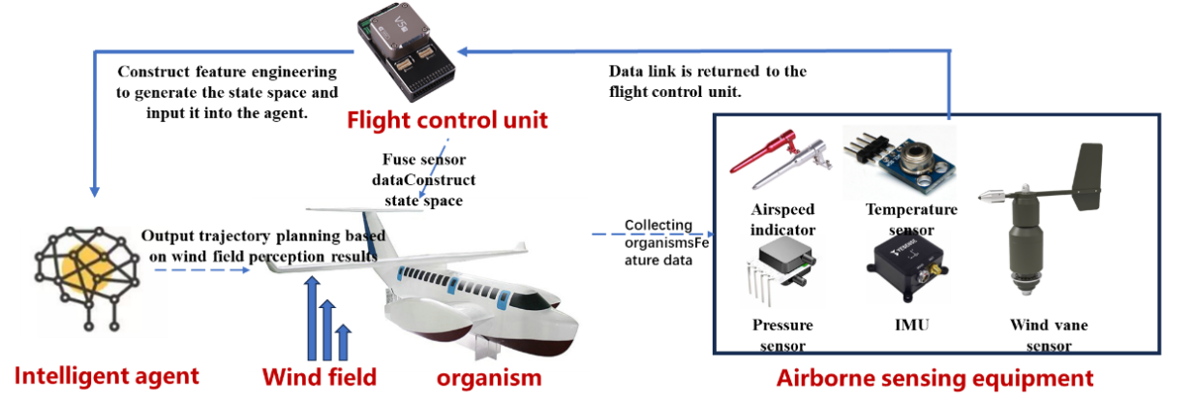
Figure 7. Technology Roadmap

4.4 Intelligent Dynamic Flight Path Planning Based on Reinforcement Deep Learning
Due to the highly time-variant and unpredictable nature of wind field models, relying on pre-trained models cannot adapt to the dynamic changes in wind fields in a timely manner, resulting in the inability to accurately harness wind energy. Therefore, online learning becomes a necessary approach to address this issue. The intelligent dynamic flight path planning method based on reinforcement deep learning continuously acquires and processes real-time wind field data during the flight and adjusts the model parameters in real time. In this way, the AI system can dynamically update its understanding of the wind field, ensuring quick optimization of flight paths and energy usage under different jet stream conditions.
(1) Data Acquisition and Processing
In deep reinforcement learning, data acquisition and processing are crucial stages that directly impact the performance and learning efficiency of the model. In reinforcement learning, the agent interacts with the environment to gather data. The agent selects actions based on the current policy, and the environment provides feedback in the form of rewards and new states in response to those actions. This process can be described as:
（5）
Specifically, in the flight path planning based on wind energy acquisition discussed in this paper, the state space of the deep learning network consists of the environmental state, aircraft state, and target state.
Using the 3D wind field measurement technology proposed earlier, real-time high-altitude wind field data is obtained through meteorological sensors or remote sensing technology, and the current flight status and historical attitude information are acquired via the flight control unit. This allows for the construction of a two-dimensional array that includes the environmental state, aircraft state, and target state, serving as input data for the model.
Each element of the state vector includes wind speed, wind direction, current position, velocity, altitude, etc., forming a vector containing 𝑁 features. The state vector is represented as：[wind speed1,wind direction1,current position,velocity,altitude,…]
After constructing the dataset, data outlier filtering and normalization are performed to eliminate the effects of different feature dimensions.
(2) Model Training
Through online learning, the agent continuously adjusts its policy to adapt to the dynamically changing wind field environment while acquiring state data in real time. At each time step, the agent selects an action based on the current state and interacts with the environment to receive feedback in the form of rewards and new states. These data are stored in an experience replay pool for subsequent training. The overall technical roadmap is shown in the figure below.
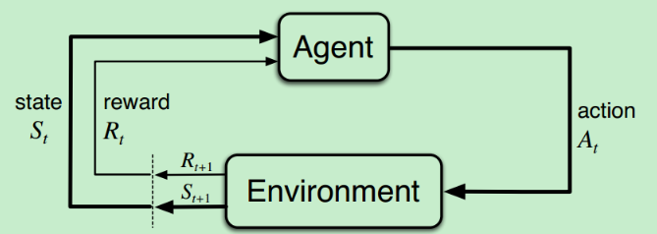
Figure 8. Strengthening Deep Learning Models
(3) Realization
Based on the trained model, an aircraft can achieve energy harvesting soaring by airbone equipment. The implementation of a real-time decision system is crucial in modern aviation technology, particularly in optimizing flight strategies for aircraft. To achieve this, the trained reinforcement learning model must be effectively deployed onto the aircraft's computing unit, which is typically a high-performance embedded system capable of processing real-time data from various sensors, including altimeters, airspeed indicators, attitude sensors, and airflow sensors. These sensors continuously collect flight status information and transmit it to the computing unit. Subsequently, the real-time decision system utilizes this sensor data to quickly perform data preprocessing and feature extraction, enabling the model to comprehend the current flight environment.
Based on the real-time received state information, the model generates corresponding flight strategies, adjusting control inputs such as heading, speed, and attitude. These adjustments not only reflect the current flight conditions but also take into account historical data and the model's predictive capabilities, allowing for dynamic adaptation. In this way, the real-time decision system can continuously optimize the aircraft's energy efficiency during flight, particularly when utilizing high-altitude jet streams for gliding. Furthermore, the system must possess a certain level of fault tolerance; in the event of sensor failure or data anomalies, it should rely on historical data and preset safety modes to execute emergency procedures, ensuring flight safety. Therefore, the implementation of a real-time decision system not only enhances flight performance but also provides a robust safeguard for aviation safety.

4.5 Cost Analysis of the Solution
(1) R&D Costs - Development of 3D Wind Field Data Collection System
Costs: Real-time wind field data collection and processing require high-performance sensors, remote sensing equipment, and related hardware, with initial investments expected to be in the millions of RMB. Additionally, the cloud computing resources or local high-performance computing devices needed for data storage and processing will also increase costs, with expected annual maintenance fees in the hundreds of thousands of RMB.
Duration: The development cycle for the data collection and processing system typically ranges from 1 to 2 years, depending on the complexity of the equipment and integration requirements.
Risks: The real-time nature and accuracy of the data may be limited by environmental conditions, equipment sensitivity, etc., leading to the need for additional calibration and system adjustments.
(2) R&D Costs - Development of Reinforcement Learning Model
Costs: Building a deep reinforcement learning model requires high-performance computing resources (such as GPU clusters) and an AI algorithm development team, with initial investments expected to be in the hundreds of thousands of RMB. Costs for software platform licenses and data processing tools used in model development also need to be considered.
Labor Costs: The development of the reinforcement learning model requires collaboration between AI experts, meteorologists, and flight control engineers, with the team's labor costs expected to be several hundred thousand RMB annually.
Duration: The AI model development and optimization cycle is expected to take 1 to 2 years, depending on the complexity of the model and the amount of data.
(3) R&D Costs - Experimental Validation
Costs: To ensure the safety and accuracy of the flight path planning system, experimental validation is required. Renting or building flight experimental equipment and testing environments is expected to require initial investments of around tens of millions of RMB.
Consumables and Samples: During the testing process, consumables (such as sensors and testing devices) and the manufacturing and maintenance costs of the test aircraft are expected to amount to several hundred thousand RMB annually.
Duration: The experimental validation cycle is expected to take 1 to 2 years.
(4) Production Costs
Table 2. Production Costs
 | Content | Expense | Period
System hardware production | Construct an automated production line for wind field perception and flight control systems, including sensors, communication equipment, flight control systems, etc | 5 million RMB | 1-2 years
Raw material procurement | The required hardware components (such as sensors, chips, etc.) depend on market prices and procurement quantities | 4 million RMB | months
Labor costs | Wages paid to operators and technicians | 8 million RMB | Ongoing

(5) Operating and Maintenance Costs
Table 3. Operating and Maintenance Costs
 | Content | Expense | Period
Maintenance of Wind Farm Data System | Regular maintenance and sensor replacement of wind field perception system | The estimated annual cost is several million RMB. | Once a year
Software system maintenance | Software updates and maintenance of flight control system | Expected annual cost of several million RMB | On-demand

4.6 Benefit Analysis
- Fuel Cost Savings: By optimizing flight path planning and wind energy capture through AI, aircraft can effectively reduce fuel consumption, resulting in long-term savings on operating costs.
- Extended Equipment Lifespan: Predictive maintenance and AI optimization of the wind field perception system can extend the equipment's lifespan, thereby reducing maintenance and replacement costs.
- Policy Support: Green aviation technologies are expected to receive government subsidies and tax incentives, thereby lowering project implementation costs.

4.7 Feasibility Analysis
(1) Technical Feasibility - Wind Field Data System Maintenance
Current Status: High-precision meteorological sensors and remote sensing technologies currently exist to obtain wind field data in real time, but their application in flight path planning is still in the development stage. By combining AI with wind field data, flight trajectories can be dynamically adjusted for more efficient wind energy utilization.
Challenges: The high temporal variability and unpredictability of wind fields increase the complexity of data collection and processing. Furthermore, the precision of sensors, the stability of data transmission, and the real-time processing capabilities of the flight control system impose higher technical requirements.
Solutions: By employing edge computing technology, large amounts of real-time data can be processed locally, reducing data transmission delays. Additionally, integrating high-precision sensors with intelligent flight control algorithms ensures the timeliness and accuracy of data. Furthermore, AI technology can dynamically optimize data processing strategies, adjusting flight path planning under varying wind field conditions.
(2) Technical Feasibility - Development and Optimization of Reinforcement Learning Models
Current Status: Reinforcement learning has achieved significant results in the fields of autonomous driving and automatic control, and its applications in aviation are gradually being explored. By integrating wind field data, reinforcement learning can adjust strategies based on real-time environments, gradually optimizing flight paths.
Challenges: Due to the complexity of wind field conditions, the real-time adjustment and iteration speed of models require high computational resources. Additionally, the complexity of online learning and its real-time coupling with aircraft performance are also key challenges.
Solutions: By introducing efficient reinforcement learning algorithms, such as multi-objective optimization algorithms based on deep neural networks, model parameters can be dynamically adjusted during flight. Furthermore, utilizing a combination of cloud computing and edge computing can improve computational efficiency and model response speed.
(3) Technical Feasibility - Energy Management and Optimization for Aircraft
Current Status: Modern drones have basic energy management capabilities, but optimization technologies that combine flight path planning with wind energy capture are not yet mature. Through AI technology, energy management systems can intelligently allocate battery power and utilize wind energy, thereby extending flight time.
Challenges: Accurate algorithms and sensor support are needed for real-time optimization of battery usage and wind energy capture. Additionally, ensuring safety and system stability is also a critical issue.
Solutions: Introducing AI for optimizing energy management can dynamically allocate energy resources. At the same time, by combining multi-source data fusion technology, changes in the wind field can be accurately assessed to maximize energy utilization efficiency.
(4) Economic Feasibility - Research and Development Costs
Initial Investment: The initial investment for real-time wind field data collection, reinforcement learning model development, and flight control system hardware design and experimental verification requires substantial funding and technical input. In particular, the costs for developing sensors for wind field data and AI algorithms are high, with the initial investment expected to be in the hundreds of millions of RMB.
Long-term Benefits: By optimizing flight trajectories and energy utilization, reducing fuel consumption and maintenance costs, significant cost savings can be achieved over the long term. Additionally, with the continuous promotion of green aviation technology and policy support, the potential for renewable energy technology in the market is enormous, expected to bring considerable economic returns to enterprises.
(5) Economic Feasibility - Business Model
Leasing and Sharing Model: For the trajectory planning system and intelligent flight control technology, a hardware and software leasing and sharing model can be adopted to reduce customers' initial purchase costs and improve the promotion and utilization rates of the technology.
Policy Support: With the promotion of environmentally friendly and low-carbon technologies, the government is expected to encourage enterprises and manufacturers to adopt such renewable energy technologies through subsidies, tax reductions, and other means, further reducing the overall implementation costs of the project.
(6) Environmental Impact
Reducing Carbon Emissions: By utilizing wind energy for smarter trajectory planning, drones and other aircraft can significantly reduce fuel consumption, thereby lowering carbon emissions. This technology aligns with global carbon reduction goals and contributes to sustainable development.
Challenges: Although the electrification of aircraft can reduce carbon emissions during operation, there will still be some environmental impact during the production and maintenance of equipment, such as the manufacturing and recycling processes for sensors and batteries.
Solutions: Using environmentally friendly materials and sustainable production processes can minimize the environmental impact during equipment manufacturing. Additionally, establishing a comprehensive system for equipment recycling and reuse can help reduce environmental burdens.

5.0 Conclusions
In summary, this study first clarifies the specific definition of green aviation. Through a questionnaire survey and data analysis, it concludes that green aviation refers to the efficient utilization of energy by aircraft, which includes enhancing energy efficiency and adopting sustainable energy sources. Consequently, this research selects wind energy as a green energy source and explores methods for its efficient utilization. By studying birds in nature, we discovered that aircraft can extract energy from the wind by flying along specific trajectories in wind fields, similar to how birds glide. Therefore, the core issue of wind energy acquisition lies in trajectory planning. To address this, this study proposes an AI-based trajectory planning method, aiming for aircraft to harness high-altitude jet streams for wind energy acquisition. Analysis shows that aircraft can achieve effective energy-harvesting flight through AI-trained trajectory planning methods. This research provides a new direction for enhancing aircraft energy efficiency and reducing greenhouse gas emissions.

References
- Lyle, C. Beyond the ICAO’s CORSIA: Towards a more climatically effective strategy for mitigation of civil-aviation emissions.
- ICAO. CORSIA and COVID-19. 2020. Available online: https://www.icao.int/environmental-protection/CORSIA/Pages/
- Lee, D. S., Pitari, G., Grewe, V., Gierens, K., Penner, J. E., Petzold, A., ... & Sausen, R. (2010). Transport impacts on atmosphere and climate: Aviation. Atmospheric environment, 44(37), 4678-4734.
- Correia, A. W., Peters, J. L., Levy, J. I., Melly, S., & Dominici, F. (2013). Residential exposure to aircraft noise and hospital admis-sions for cardiovascular diseases: multi-airport retrospective study. Bmj, 347
- Hagmann, C., Semeijn, J., & Vellenga, D. B. (2015). Exploring the green image of airlines: Passenger perceptions and airline choice. Journal of Air Transport Management, 43, 37-45.
- Vespermann, J., & Wittmer, A. (2011). Financial, ecological and managerial impacts of emission trading schemes: the case of Lufthansa. Business Strategy and the Environment, 20(3), 174-191.
- Zhang, Y. J., Shi, W., & Jiang, L. (2020). Does China's carbon emissions trading policy improve the technology innovation of relevant enterprises?. Business Strategy and the Environment, 29(3), 872-885.
- Agarwal R K. Review of technologies to achieve sustainable (green) aviation[J]. Recent advances in aircraft technology, 2012, 19: 427-464.
- Afonso F, Sohst M, Diogo C M A, et al. Strategies towards a more sustainable aviation: A systematic review[J]. Progress in Aerospace Sciences, 2023, 137: 100878.
- Ficca A, Marulo F, Sollo A. An open thinking for a vision on sustainable green aviation[J]. Progress in Aerospace Sciences, 2023, 141: 100928.
- Qiu R, Hou S, Chen X, et al. Green aviation industry sustainable development towards an integrated support system[J]. Business Strategy and the Environment, 2021, 30(5): 2441-2452.
- Perez-Valls, M. , Cespedes-Lorente, J. , & Moreno-Garcia, J. (2016). Green practices and organizational design as sources of stra-tegic flexibility and performance. Business Strategy and the Environment, 25(8), 529-544.
- Hoelzen J, Silberhorn D, Zill T, et al. Hydrogen-powered aviation and its reliance on green hydrogen infrastructure–Review and research gaps[J]. International Journal of Hydrogen Energy, 2022, 47(5): 3108-3130.
- Blockley R. Green aviation[M]. John Wiley & Sons, 2016.
- Platzer M F. The prospects for green aviation by 2050[J]. Progress in Aerospace Sciences, 2023, 141: 100926.
- Perez-Valls, M. , Cespedes-Lorente, J. , & Moreno-Garcia, J. (2016). Green practices and organizational design as sources of stra-tegicflexibility and performance. Business Strategy and the Environment, 25(8), 529-544.
- Ranasinghe K, Guan K, Gardi A, et al. Review of advanced low-emission technologies for sustainable aviation[J]. Energy, 2019, 188: 115945.
- Lai Y Y, Christley E, Kulanovic A, et al. Analysing the opportunities and challenges for mitigating the climate impact of aviation: A narrative review[J]. Renewable and Sustainable Energy Reviews, 2022, 156: 111972.
- Tobalske B W. Biomechanics of bird flight [J]. Journal of Experimental Biology, 2007, 210(18): 3135-46.
- Tucker V A, Parrott G C. Aerodynamics of Gliding Flight in A Falcon and Other Birds [J]. Journal of Experimental Biology, 1970, 52(2): 345-67.
- Norberg U M. Gliding Flight [M]. Vertebrate Flight: Mechanics, Physiology, Morphology, Ecology and Evolution. Berlin, Heidelberg; Springer Berlin Heidelberg. 1990: 65-75.
- Beaumont F, Murer S, Bogard F, et al. Aerodynamic Interaction of Migratory Birds in Gliding Flight [J]. Fluids, 2023, 8(2).
- Steele J H. Spatial Heterogeneity and Population Stability [J]. Nature, 1974, 248(5443): 83-.
- Harvey C, Inman D J. Aerodynamic efficiency of gliding birds vs comparable UAVs: a review [J]. Bioinspiration & Biomimetics, 2021, 16(3).
- Rayleigh, J.W.S. (1883). The Soaring of Birds. Nature, 27, 534-535.

